Labsheet-2

Mapreduce

export PATH=$PATH:$HADOOP_HOME/bin:$HADOOP_HOME/sbin

cd $HADOOP_HOME/sbin

./start-all.sh  
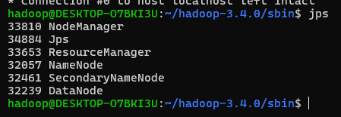

*1 hdfs dfs -mkdir /bigdata*

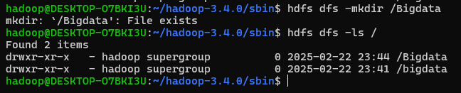

*2 hdfs dfs -touchz /bigdata/input*

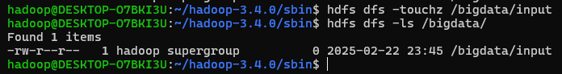

*3 hdfs dfs -appendToFile -/bigdata /input*

*aaaaa bbbb cc aaaaa cc*

*cc bbbb zzzz ctrl+d ctrl+ d*

**

*5 cd $HADOOP_HOME*

*6 ls*

**

*7 cd share*

*8 ls*

*9 cd Hadoop*

*10 ls*

*11 cd mapreduce*

*12 ls*

***hadoop-mapreduce-client-app-3.3.0.jar***

***hadoop-mapreduce-client-common-3.3.0.jar***

***hadoop-mapreduce-client-core-3.3.0.jar***

***hadoop-mapreduce-client-hs-3.3.0.jar***

***hadoop-mapreduce-client-hs-plugins-3.3.0.jar***

***hadoop-mapreduce-client-jobclient-3.3.0.jar***

***hadoop-mapreduce-client-jobclient-3.3.0-tests.jar***

***hadoop-mapreduce-client-nativetask-3.3.0.jar***

***hadoop-mapreduce-client-shuffle-3.3.0.jar***

***hadoop-mapreduce-client-uploader-3.3.0.jar***

***hadoop-mapreduce-examples-3.3.0.jar***

*jdiff*

*lib-examples*

*sources*

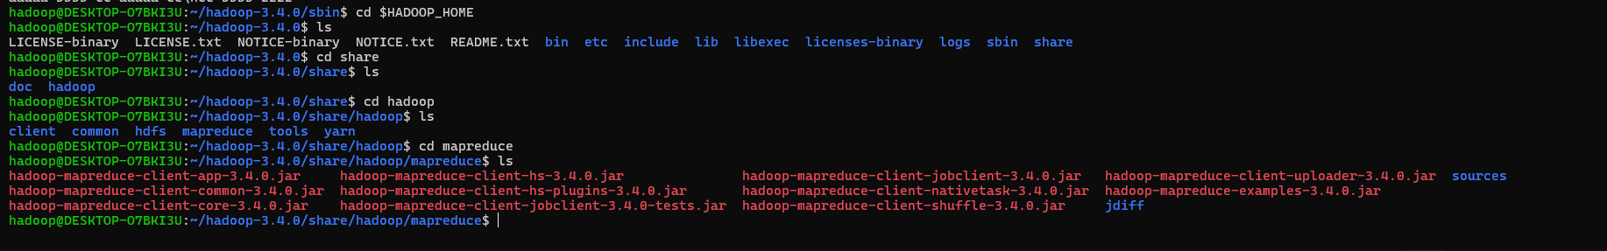

*13 hadoop jar* ***hadoop-mapreduce-examples-3.3.0.jar*** *wordcount /bigdata /out*

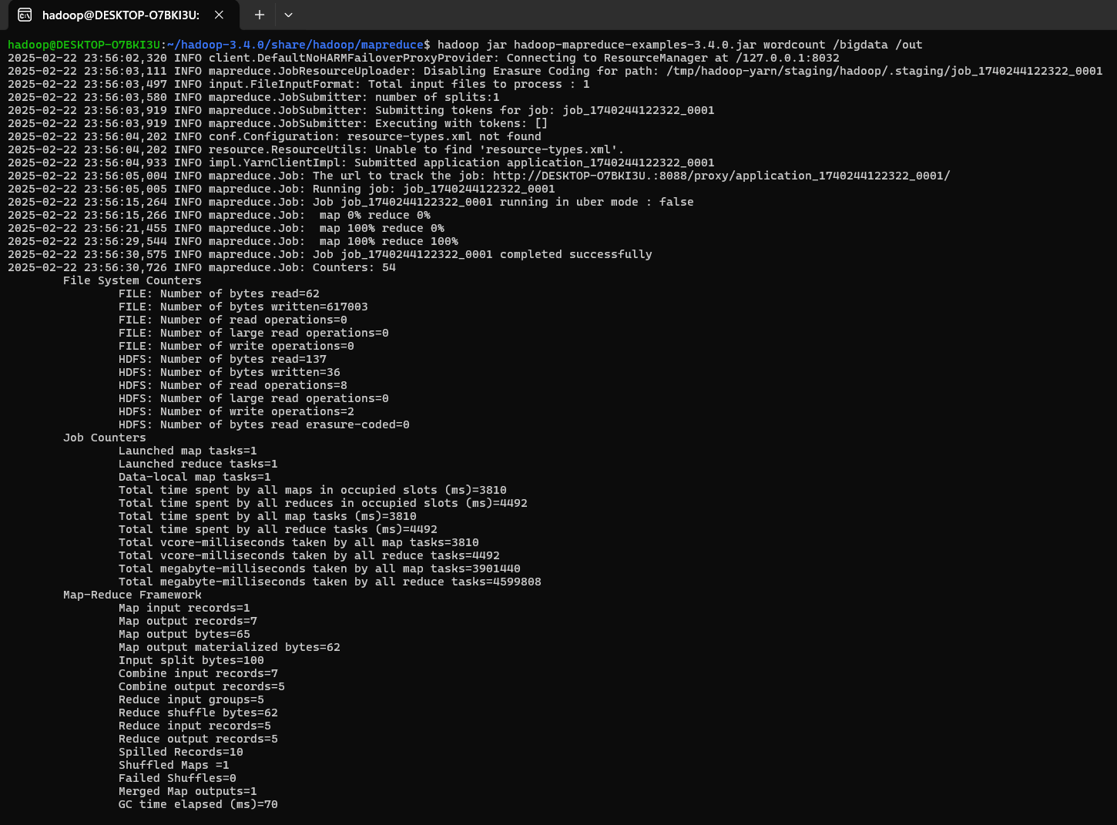

*14 hdfs dfs -ls /out*

*Found 2 items*

*-rw-r--r-- 1 hadoop supergroup 0 2023-04-03 15:20 /output/_SUCCESS*

*-rw-r--r-- 1 hadoop supergroup 63 2023-04-03 15:20 /output/part-r-00000*

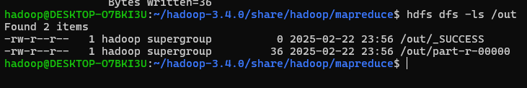

*15 hdfs dfs -cat /out/part\**

*aaaaa 2*

*bbbb 2*

*cc 3*

*zzzz 1*

